**VOC Summarization**

**Architecture diagram:**

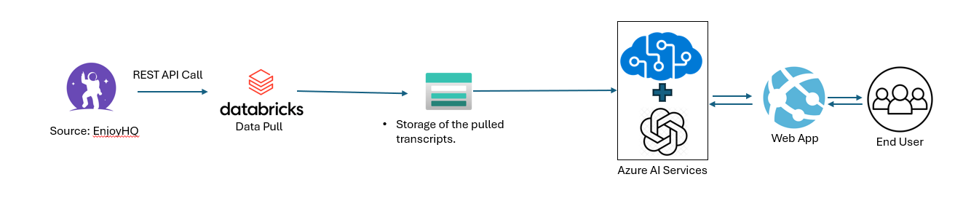

1. **List of Azure resource group to be created:**
2. Web app service
3. Cognitive Search service
   1. Indexer
   2. Index
   3. Data source
4. Azure Blob storage
5. Open AI Service
6. Databricks setup - Databricks notebook need to be created for Prod to extract transcripts from EnjoyHQ to databricks storage.
7. **Data injection:**

Python script in Databricks will be executed twice daily and transcript files are copied into Azure Blob storage.

**ingestionpoc/Source-Conversations/EnjHQ/CodeFixCheck/**

**Step 2:** Copying data from DBFS to Azure blob storage.

Cognitive search indexer will be executed, and data is indexed in the index on schedule basis.

1. Databricks Resources

https://adb-1943773873358740.0.azuredatabricks.net/?o=1943773873358740#notebook/3129209821746893/command/3129209821746894